Documentation Template

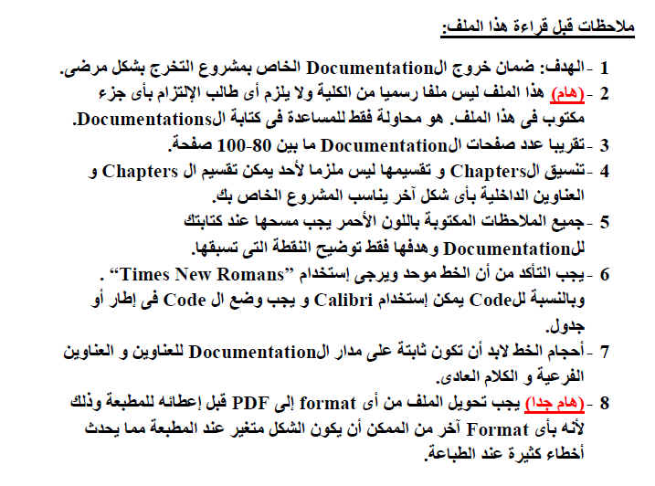


Ain Shams University
Faculty of Computer & Information Sciences

Scientific Computing Department

Steering Angle and Speed prediction for Self-Driving Car

[On this cover page put a background image suitable for your project]

June 2020

Ain Shams University
Faculty of Computer & Information Sciences

Scientific Computing Department

Steering Angle and Speed prediction for Self-Driving Car

This documentation submitted as required for the degree of bachelors in Computer and Information Sciences.

By

Ahmed Araby Kamel [Scientific Computing]

Under Supervision of

[Supervisor 1]
[Supervisor Title],
Scientific Computing Department,

Faculty of Computer and Information Sciences,
Ain Shams University.

[Supervisor 2]
[Supervisor Title],
Scientific Computing Department,

Faculty of Computer and Information Sciences,
Ain Shams University.

June 2020

Acknowledgements | 1

Acknowledgements

All praise and thanks to ALLAH, who provided me the ability to complete this work. I hope to accept this work from me.

I am grateful of my parents and my family who are always providing help and support throughout the whole years of study. I hope I can give that back to them.

I also offer my sincerest gratitude to my supervisors, Prof. Dr. ………………,
Dr. Marym Nabil and T.A. Basel Safwat who have supported me throughout my thesis with their patience, knowledge, and experience.

Finally, I would thank my friends and all people who gave me support and encouragement.

Abstract | 2

Abstract

The project aims to develop a deep learning model that drive a car in high speed roads which will help people to use this time in more useful way than driving, also this could help people with disabilities, to solve this problem different approaches were investigated, classical approach (primitive) steering the car based on the geometry of the road lane lines using line detection algorithms i.e. Hough line algorithm, beside resulting in very poor performance there no speed prediction achieved, deep learning approach (state of the art) by developing a model that predict the steering angle and speed using the images of the scene of the road that comes from a static camera mounted in front of the car to achieve second level of autonomy for a self-driving car, Udacity self-driving car simulator is used to test the performance of the model in real time.

Table of Contents

[At the end of each line put page number]

Acknowledgements.…….……..……………………………………….1

Abstract………….………………...……………………………………2

List of Figures….………………………………...………………………

List of Tables…………...………………………..……….……………...

List of Abbreviations….……………………..…………….……………

Chapter 1: Introduction…………………………………………...……

1.1 Problem Definition………………………………………….........
  - History……………………………………………

  - Applications………………………………………

[Gives an introduction to your project.]

[State problem definition in points.]

1.2 Motivation……………………………………………………........
[State Motivation for your project]
1.3 Objectives……………………………………………………........

[State objectives in points.]

1.4 Time plan…………………………………………………….........

[State time plan in a chart like Gantt chart.]

1.5 Documentation Outline..............……………………………........

[This is one page stating the rest of documentation. Like chapter 2 talks about … and chapter 3 talks about… and so on]

Chapter 2: Background…………………….……………..…………….

[The objectives of this chapter are to give the reader the required literature review, survey, mathematical background, algorithms and techniques required.]

Chapter 3: System Architecture.......…………………………..

[Architecture design showing main components of the systems and the relations between these components]

Chapter 4: System Implementation…..........…………………………..

[Try to classify this chapter to main components describing your detailed implementation of system architecture.]
[ Don’t put any code, only flowcharts and pseudocode of your algorithms]
[ Add your results and discussion on each component]

Chapter 5: System Testing....………………………..

[How can I test and run your application. Clarify this with screen shots]

Chapter 6: Conclusion and Future Work………….…………………..

6.1 Conclusion…………………………………………………………

[Summarize your project and states the advantages and disadvantages of your project.]

6.2 Future Work………………………………………………………

[Open points in your project that can be continued in the next year.]

TOOLS……….……………………………………………………………….…….

[Tools used in the project. If you can classify it to hardware and software tools]

REFERENCES……………………………………………………………….…….

[Write books and papers firstly ordered by date then websites. You must refer to references in the documentation].

Examples of how to write references:

If book

[1] William Stalling, “Cryptography and Network Security Principles and Practices”, Fourth Edition, Prentice Hall, November 16, 2005.

If paper

[2] Eslam Gamal Ahmed, Eman Shabaan, Mohamed Hashem, “Lightweight Mutual Authentication Protocol for Low cost RFID Tags”, International Journal of Network

Security & Its Application (IJNSA), Academy & Industry Research Collaboration Center (AIRCC), April 2010, Vol.2, No.2, PP.27-37.

If website:

[3] http://www.buzzle.com/articles/rfid-vs-barcode.html, Last Retrieved on 27/06/2012.

This date is the last date you visited the website.

List of Figures

List of Figures

[State all figures in your documentation with page number]

Format

Chapter number.Figure number: Figure title……………………...………………….page number

For example

Figure 1.1: Time Plane ……..………………………………………………………11

Figure 1.2: System Architecture….………………………………………………20

List of Tables

List of Tables

[State all tables in your documentation with page number]

Format

Chapter number.Table number: Figure title……………………...………………….page number

For example

Table 1.1: Results of (….).……………...……………………………………21

Table 1.2: System Advantages and Disadvantages…….……………………………39

List of Abbreviations

List of Abbreviations

[State all abbreviations in your documentation]

Format

Abbreviation: What Abbreviation means

For example

SVM: Support Vector Machine

NN: Neural Network

Chapter One:

Introduction

1.1 Problem Definition………………………………………….........
- History……………………………………………
- Applications………………………………………

1.2Motivation……………………………………………………........
1.3 Objectives……………………………………………………........
1.4 Time plan……………………………………………………......
1.5 Documentation Outline..............……………………………........

[Repeat this page at the beginning of each chapter with the title and points of each chapter]

